**Effects of climate and trade policies on global energy trade networks**

Supplementary Material

Jun Shepard, Bas J. van Ruijven, Behnam Zakeri

# 1 Converting trade data to physical energy flows

To link the BACI trade and IEA world energy balance (WEB) databases, I rely on a correspondence table that defines specific energy (MJ/kg) for each representative energy resource in the MESSAGE model. This specific energy value is region specific for crude (CRU) and coal (COAL), for which quality can vary by geographic source. This concordance is built using the following method:

**Coal:** Use the share of (lignite + sub-bituminous) compared to share of (bituminous + anthracite) in reserves, sourced from the BP Statistical Workbook (2007). Use a representative specific energy for each type of coal and find the lignite-subbituminous average and bituminous-anthracite average. Calculate the weighted average for a country (where country-specific data are available) or a region (where country-specific data are not available). Representative specific energy values are sourced from the Indiana Center for Coal Technology Research at Purdue University

|  |  |
| --- | --- |
| **Coal Type** | **Representative specific energy value (MJ/t)** |
| Anthracite | 30,080 |
| Bituminous | 32,000 |
| Lignite | 16,000 |
| Sub-bituminous | 21,000 |
| Mean (Lignite + Sub-bituminous) | 18,500 |
| Mean (Anthracite + Bituminous) | 31,040 |

**Table 1.** Representative specific energy for coal, by type.

**Crude:** crude oil reserves vary in terms of weight (light to heavy) and sulfur content (sour to sweet). To differentiate specific energy values, we focus on variation in weight by region. We apply the following formula to obtain barrels of oil per ton using the representative API gravity for each benchmark crude, which are sourced from Petroleum.co.uk:

$$barrels per ton=\frac{API+131.5}{141.5×0.159}$$

|  |  |
| --- | --- |
| **Crude Benchmark** | **Representative API** |
| West Texas Intermediate (WTI) | 39.6 |
| Brent | 38.06 |
| Dubai | 31 |
| Orb (OPEC) | 32.7 |
| Minas | 35 |
| Tapis | 45.2 |
| Bonny Light | 32.9 |
| Isthmus Light | 33.74 |

**Table 2.** Representative API for crude, by type.

Petroleum (PET), nuclear-uranium (NUC), bioenergy-biodiesel and peat (BIO) are not region-specific.

# 2 Data validation for representative countries

Figures 1a-d show the IEA-BACI data validation for representative countries (China, Germany, Japan, Brazil).

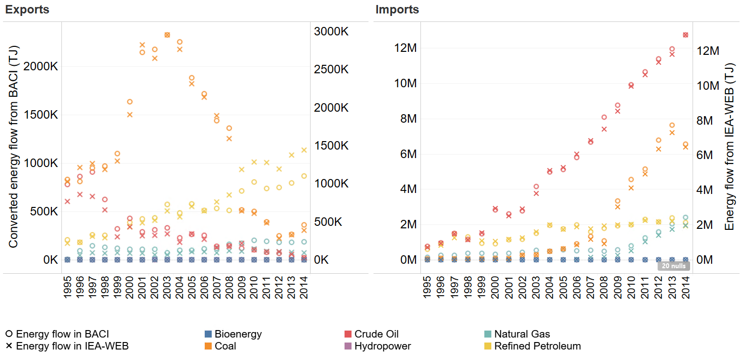

**Figure 1a.** Validating converted trade data (BACI) with energy data (IEA) for China**.**

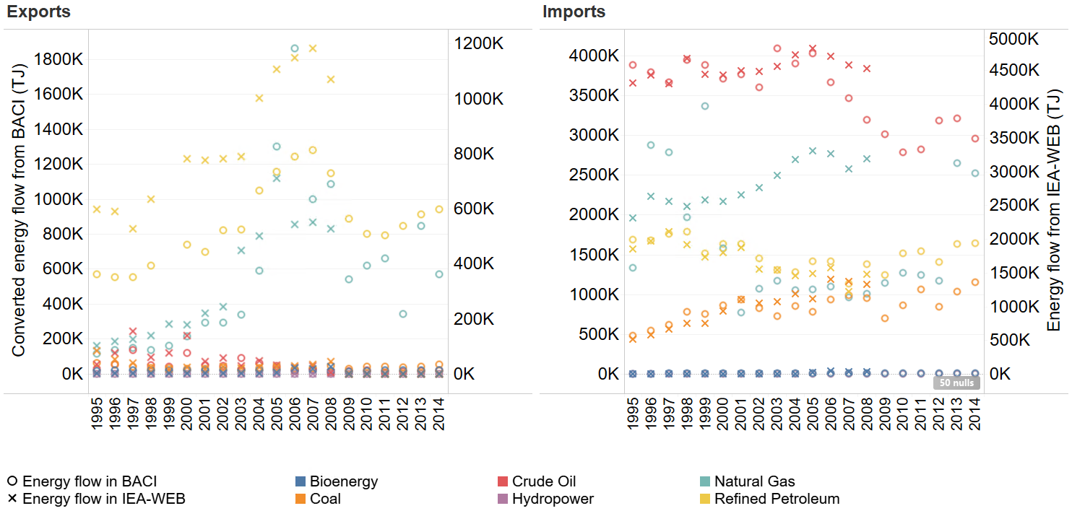

**Figure 1b.** Validating converted trade data (BACI) with energy data (IEA) for Germany**.**

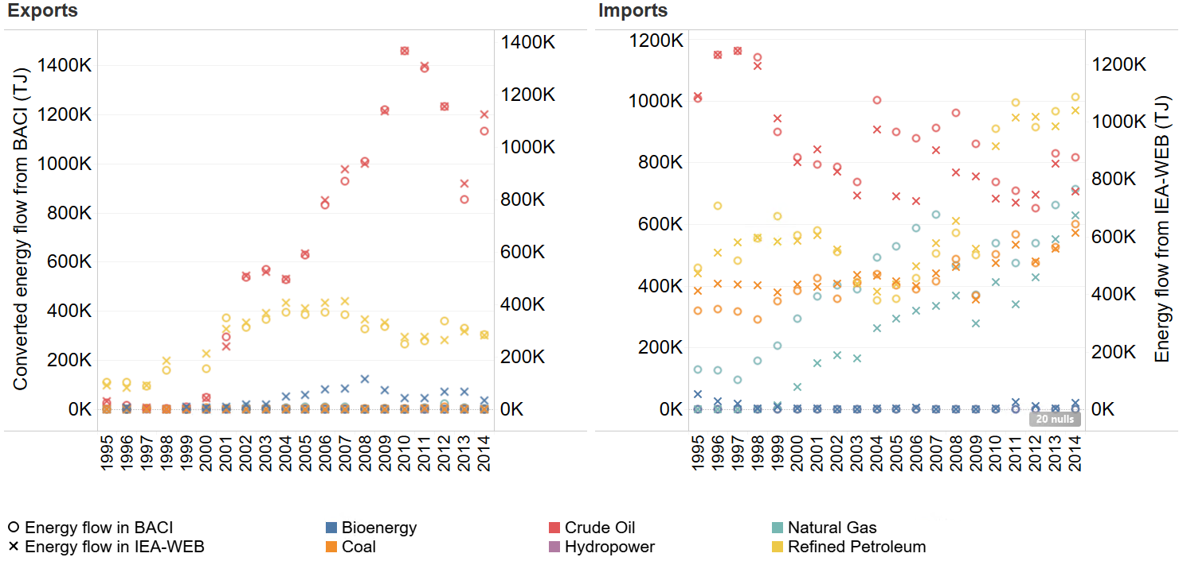

**Figure 1c.** Validating converted trade data (BACI) with energy data (IEA) for Japan**.**

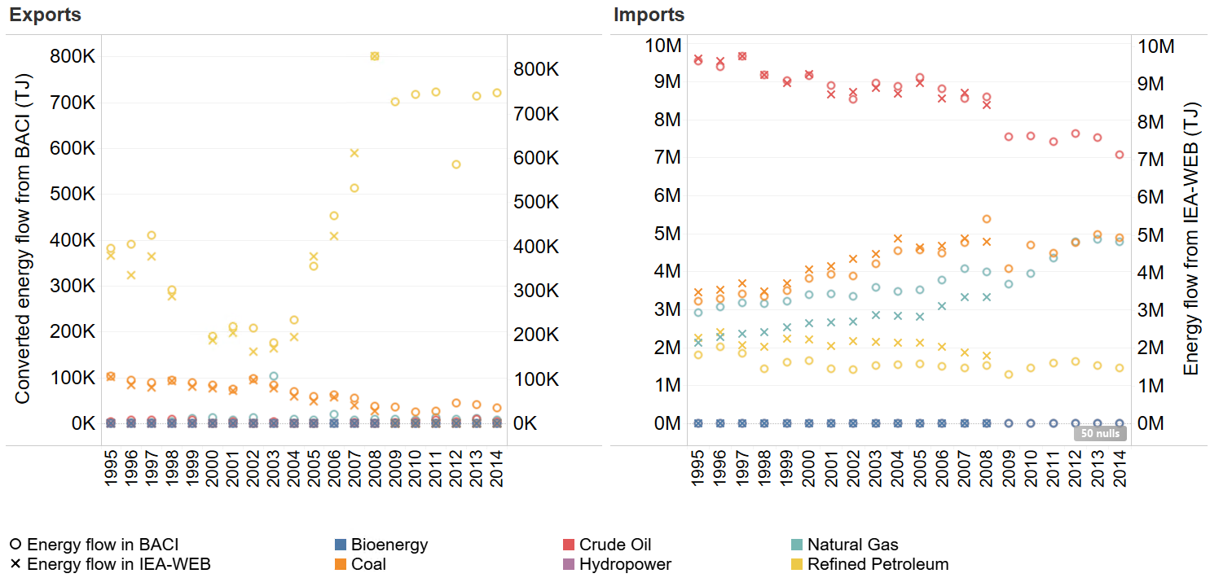

**Figure 1d.** Validating converted trade data (BACI) with energy data (IEA) for Brazil**.**

# 3 Country to region correspondence

The following table presents the country to region correspondence used for this study. Note that we use the most disaggregated MESSAGE global model to date, which includes 14 representative regions.

|  |  |
| --- | --- |
| MESSAGE Region | Countries |
| Africa (AFR) | Angola, Benin, Burkina Faso, Burundi, Cameroon, Cabo Verde, Central African Republic, Chad, Comoros, Cote d’Ivoire, Djibouti, Equatorial Guinea, Eritrea, Ethiopia, Gabon, Gambia, Ghana, Guinea, Guinea-Bissau, Kenya, Liberia, Madagascar, Malawi, Mali, Mauritania, Mauritius, Mozambique, Niger, Nigeria, Rwanda, Sao Tome and Principe, Senegal, Seychelles, Sierra Leone, Somalia, South Africa, Sudan, Tanzania, Togo, Uganda, Zambia, Zimbabwe |
| Central Asian States (CAS) | Kazakhstan, Kyrgyzstan, Tajikistan, Turkmenistan, Uzbekistan |
| Centrally Planned Asia (CPA) | Cambodia, China, Laos, Mongolia, North Korea, Vietnam, Taiwan |
| Eastern Europe (EEU) | Albania, Bosnia Herzegovina, Bulgaria, Croatia, Czech Republic, Estonia, Hungary, Latvia, Lithuania, Montenegro, Poland, Romania, Serbia, Slovakia, Slovenia |
| Latin America (LAM) | Antigua and Barbuda, Argentina, Bahamas, Barbados, Belize, Bermuda, Bolivia, Brazil, Chile, Colombia, Costa Rica, Cuba, Dominican Republic, Ecuador, El Salvador, Falkland Islands, Guatemala, Guyana, Haiti, Honduras, Jamaica, Mexico Nicaragua, Panama, Paraguay, Peru, Suriname, Trinidad and Tobago, Uruguay, Venezuela |
| Middle East (MEA) | Algeria, Bahrain, Egypt, Iran, Iraq, Israel, Jordan, Kuwait, Lebanon, Libya, Morocco, Oman, Qatar, Saudi Arabia, South Sudan, Syria, Tunisia, United Arab Emirates, Yemen |
| North America (NAM) | Canada, United States |
| Pacific OECD (PAO) | Australia, Japan, New Zealand |
| Pacific Asia (PAS) | Brunei Darussalam, Fiji, French Polynesia, Indonesia, Malaysia, Myanmar, New Caledonia, Republic of Korea, Papua New Guinea, Philippines, Samoa, Singapore, Solomon Islands, Thailand, Timor-Leste, Vanuatu |
| Russia (RUS) | Russia |
| South Asia (SAS) | Afghanistan, Bangladesh, Bhutan, India, Maldives, Nepal, Pakistan, Sri Lanka |
| South Caucasus States (SCS) | Armenia, Azerbaijan, Georgia |
| Belarus, Moldova, Ukraine (UBM) | Belarus, Moldova, Ukraine |

**Table 3.** Region to country correspondence in MESSAGE R14.

# 4 Tariff rate aggregation

Tariffs are endogenous to trade flow; while tariffs can impact the amount of imports to a country, the amount of imports can also influence whether and how much a tariff is imposed. This poses an issue when aggregating tariff rates so that they are identified by MESSAGEix-represented region. To address this endogeneity, we follow the aggregation methodology put forth in Guimbard et al. (2012) and Bouët et al. (2008) [29,30]. We first cluster countries into reference groups by GDP and trade openness. This gives us an exogenous group of countries to compare variations in tariff rates. We then assign weights to each observation in the WTO, defined as:

$$w_{jpet}=M_{jpet,REF}\left[\frac{M_{j...}}{M_{.....REF}}\right]$$

Where $w_{ijpet}$ is the weight for a given importer $j$, HS6 product code $p$ which is associated with energy commodity $e$, in year $t$; $M_{jpet,REF}$ are imports of $p$ to $j$ in year $t$; $M_{j...}$ is the total imports to country $j$, and $M_{.....REF}$ is the total imports to the reference group associated with $j$. Finally, we aggregate the data by calculating the importer-energy-year level mean, weighted by $w_{jpet}$.

# 5 MESSAGE parameters in global trade schema

The following table lists all parameters included in the global trade schema that required re-parameterization for the bilateral trade schema.

|  |  |  |
| --- | --- | --- |
| Parameter(s)… | Represents… | Used for… |
| Activity bounds (lower and upper) | How much an activity can be conducted by a region (e.g. how much a region can export oil) | Activity constraints |
| Capacity factor | Capacity factor of a technology (e.g. 0.75 for coal power plants) | Determining the usage of an activity |
| Emission factor | Per-unit emissions associated with an activity | Assigning costs associated with an emissions tax; estimating regional/global emissions |
| Fixed cost | Fixed costs of a technology (e.g. exports) | Cost minimization |
| Growth bounds (lower and upper) | How much an activity can be increased/decreased by a region | Dynamic constraints |
| Historical activity | Historic data on the activity of a region (e.g. historic exports) | Setting initial conditions for the model |
| Historical new capacity | Historic investment into new capacity of a technology (e.g. coal power plants) | Setting initial conditions for the model |
| Initial activity bounds (lower and upper) | How much an activity can be increased/decreased in absolute terms | Dynamic constraints |
| Input and output | The input required per unit output (e.g. input of coal into power plant is > 1, while output is < 1, due to losses) | Building relationships among technologies |
| Investment cost | Investment costs of a technology | Cost minimization |
| Levelized cost soft activity bounds (lower and upper) | Allows relaxation of cost activity bounds | Regional cost accounting |
| Activity relations | Relationships among parameters | Builds constraints for optimization |
| Soft activity bounds (lower and upper) | Allows relaxation of activity bounds that does not exceed investment | Regional capacity accounting |
| Technical lifetime | Lifetime of a technology (e.g. 20 years for power plant) | Determining when a technology is phased out |
| Variable cost | Variable costs of a technology | Cost minimization |

**Table 4.** Parameters used for global trade schema in MESSAGE.

# 6 Port selection for shortest sea routes

Shortest sea routes are selected based on a user-defined list of ports. For this study, we use the “Seaports of the World by Country” list published by the Virginia Economic Development Partnership, which includes 835 of the most active sea/inland ports in the world.

We first define the nodes to be included in the shortest sea route calculations. We set the distance between nodes for uniform nodes to two degrees and overlay this map with a map of the active ports. Figure 2 shows both uniform and port nodes:

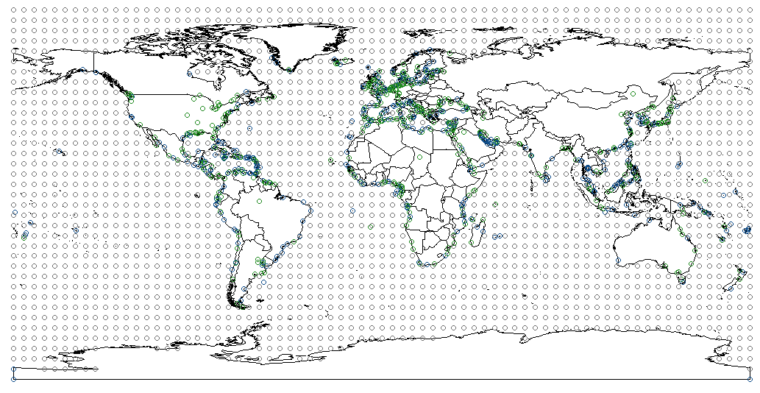

**Fig. 2.** Map of nodes used in shortest path calculation. Uniform nodes are in grey, inland water ports are in green, and sea ports are in blue.

Based on this list of $n$ nodes, the program then generates a dataset of all combinations of all nodes. Based on this dataset, we calculate the Haversine distance between the nodes and put these distances into an $n×n$ matrix. We use this matrix to run the Floyd-Warshall algorithm which, for each pair of nodes, compiles a list of intermediate nodes that produce the shortest route between them. For countries with multiple ports, we take the port-port combination that allows the shortest route for each country-country combination. Finally, we link these data to bilateral trade data for each commodity $k$.

# 7 Effect of sea distance on trade cost (details)

The following section should be read with the corresponding section in the main text (Section 2.3).

## 7.1 Measuring sea distance

We apply the Floyd-Warshall Algorithm on a set of nodes that cover major bodies of water, combined with a set of nodes at the locations of major sea and inland water ports. The set of uniform nodes are separated by 2 degrees.[1] Additionally, there can be more than one port per country; for instance, the United States has ports in the northeast (New York), southeast (New Orleans), and the west (California). The Floyd-Warshall Algorithm finds the shortest path between two nodes by adding or subtracting intermediate points based on whether they shorten or lengthen the path. We aggregate to the 14 regions represented in MESSAGEix by selecting the primary import and export ports for each region, for each energy commodity in each year. This means that the distance between regions is time-variant; it is based on the country/port that is most crucial for each commodity in a given year. A detailed framework for port selection can be found in the Supplementary Material.

## 7.2 Marginal effect of sea distance on trade cost

We estimate the marginal effect of sea distance by first building a dataset of trade flows and distances between countries for 1995-2014. To this, we add the gravity terms derived from USITC data (see Data). Using this data, we run the following ordinary least squares (OLS) specification:

$$P_{ijkt}=α+β_{1}d_{ijt}+β_{2}g_{it}+β_{3}g_{jt}+β_{4}c_{ij}+β_{5}l_{ij}+β_{6:19}Γ_{R_{i}}+β_{20:33}Θ_{R_{j}}+β_{34:53}Ψ_{t}+ϵ$$

Where:

* $P_{ijkt}$ is the per-unit cost of energy commodity $k$ that is exported from country $i$ to country $j$ in year $t$;
* $d_{ijt}$ is distance between country $i$ and country $j$;
* $g_{it}$ and $g_{jt}$ are GDP of countries $i$ and $j$ in year $t$;
* $c_{ij}$ is an indicator equal to 1 if the two countries are contiguous;
* $l_{ij}$ is an indicator equal to 1 if countries $i$ and $j$ share a common language;
* $Γ_{R_{i}}$ are fixed effects for the MESSAGEIX region corresponding to country $i$;
* $Θ_{R_{j}}$ are fixed effects for the MESSAGEIX region corresponding to country $j$;
* $Ψ_{t}$ are year fixed effects; and
* $ϵ$ is the residual.

We run this specification across all energy commodities and by energy commodity. Table 2 presents the results of these six models. Note that our coefficient of interest is $β_{1}$, or the marginal effect of each 1000km increase in bilateral distance.

|  |  |  |  |  |  |
| --- | --- | --- | --- | --- | --- |
|  | $$β_{1}$$ | Std. Err. | t-value | Pr(>|t|) | Mean(Y) |
| All energy commodities | 0.0031 | 0.0001 | 26.4550 | 0.0000 | 326.3215887 |
| Coal | 0.0000 | 0.0002 | 0.0973 | 0.9225 | 255.1141421 |
| Crude Oil | 0.0055 | 0.0002 | 22.7109 | 0.0000 | 181.8138803 |
| Petroleum Products | 0.0036 | 0.0002 | 21.1065 | 0.0000 | 395.9311973 |
| LNG | 0.0032 | 0.0003 | 10.8340 | 0.0000 | 333.1324012 |

**Table 5.** Results of gravity model-based regression. The first column displays the coefficient on distance, or the marginal effect of distance on trade cost. The second column displays the standard error on this coefficient, the third column displays the t-value, the fourth column displays the p-value, and the fourth displays the mean Y-value ($1000/t of the given commodity).

Model results suggest that there is significant heterogeneity across energy commodity. For instance, the trade costs of LNG and fuel oil tend to be more sensitive to distance than crude oil. We therefore use an energy-specific marginal effect to parameterize the distance-based variable cost.[2] For ethanol and methanol, we assume the same distance-based variable cost coefficient as petroleum products. For liquid hydrogen, we assume the same distance-based cost coefficient as LNG.

Finally, to build the variable cost parameter used in MESSAGEix, we multiply the region-to-region sea distances by the marginal effect:

$$varcost_{R_{i}R_{j}kt}=β_{1k}×d_{R_{i}R_{j}kt}$$

Note that variable cost is identified by exporting region ($R_{i}$), importing region ($R_{j}$), energy commodity $k$, and year $t$. This is because the sea distance we calculated is differentiated by region pairs and energy commodity. Figure 4 below presents the distribution of distance-based variable costs.

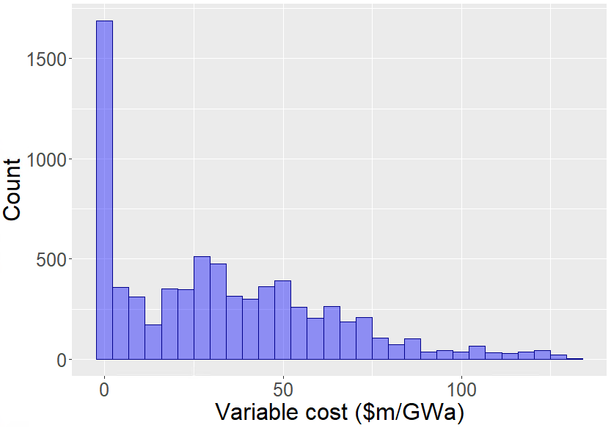

**Fig. 3.** Distribution of estimated variable costs based on regression analysis. This is the distance-based variable cost, so the product of $β_{1}$ and bilateral distance, where $β_{1}$ is differentiated by energy commodity. Variable costs will therefore be uniquely identified by region, energy commodity, and year.

# 8 Shipping constraints, assumptions, and costs

We add the following constraints in MESSAGEix to represent global shipping capacities:

$$\sum_{k^{liquid}}{\left(liquid_shipping_{R_{i}ft}\right)-\left(hv_{R_{i}ft} ×ACT_{R_{i}R_{j}k^{liquid}}\right)≥0}∀ t$$

$$\sum_{k^{solid}}{\left(solid_shipping_{R_{i}ft}\right)-\left(hv_{R_{i}ft} ×ACT_{R_{i}R_{j}k^{solid}}\right)≥0}∀ t$$

$$\sum_{k^{LNG}}{\left(LNG_shipping_{R_{i}ft}\right)-\left(hv_{R_{i}ft} ×ACT_{R_{i}R_{j}k^{LNG}}\right)≥0}∀ t$$

$$\sum_{k^{H_{2}}}{\left(H_{2}_shipping_{R_{i}ft}\right)-\left(hv_{R_{i}ft} ×ACT_{R_{i}R_{j}k^{H_{2}}}\right)≥0}∀ t$$

These equations dictate that the capacity of shipping (e.g. $liquid_shipping$) summed across all exporting regions (i.e. global capacity) must be greater than the global trade activity for a given type of commodity $k^{*}$. Here we differentiate shipping capacity by what they carry ($k^{*}$) and the fuel they use ($f$). In this study, $k^{liquid}$ includes crude oil, light oil, and fuel oil; $k^{solid}$ includes coal; and $k^{LNG}$ includes LNG. $f$ can be fuel oil (i.e. diesel), LNG, or electricity. Heavy crude has historically been the primary fuel for maritime shipping. Interest has increased more recently in LNG-fueled vessels [27,28]. Electricity-powered vessels are still not in development, but we include this as an option (albeit an expensive one) for the latter period of the model horizon (post-2030). We include hydrogen-based transport as another possible but still prohibitively expensive option. $hv_{kt}$ is the conversion factor for a given energy commodity $k$ from the exporting region ($R_{i}$) in time $t$; we derive these values from the IEA NCV dataset. This allows us to have consistent units.

The following tables include costs, parameters, and assumptions used to build the constraints related to global shipping capacity in the re-parameterized MESSAGE model. More information on the shipping constraints can be found in the Methods section of the main text.

|  |  |  |  |  |
| --- | --- | --- | --- | --- |
| **Type of shipping** | **Type of fuel** | **Fuel input  (kg/bton-km-y)** | | |
| **By weight (kg/bton-km-y)** | **By energy (GWa/bton-km-y)** | **Emissions factor  (Mt/bton-km-y)** |
| Liquid | Diesel | 6894865.04 | 0.01 | 0.02 |
| Liquid | LNG | 3678751.33 | 0.00 | 0.01 |
| Liquid | Electricity | NA | 0.00 | 0.00 |
| Solid | Diesel | 7283748.84 | 0.01 | 0.02 |
| Solid | LNG | 3052216.32 | 0.00 | 0.01 |
| Solid | Electricity | NA | 0.00 | 0.00 |
| LNG | Diesel | 16810656.90 | 0.02 | 0.05 |
| LNG | LNG | 5594115.78 | 0.01 | 0.01 |
| LNG | Electricity | NA | 0.00 | 0.00 |

**Table 6.** Fuel input required by type of shipping. Based on author calculations using data from Johannson et al. (2017), International Energy Agency, International Maritime Organization, and DNV-GL [1–5].

|  |  |  |  |  |
| --- | --- | --- | --- | --- |
| **Type of shipping** | **Type of fuel** | **Capital cost** | | |
| **Overnight cost  ($M)** | **Annualized, 10%DR  ($M/y)** | **Annualized  ($M/bton-km-y)** |
| Liquid | Diesel | 76.00 | 8.37 | 6.24 |
| Liquid | LNG | 96.00 | 10.58 | 7.88 |
| Liquid | Electricity | 192000.00 | 21152.27 | 15758.19 |
| Solid | Diesel | 51.60 | 5.68 | 4.24 |
| Solid | LNG | 71.60 | 7.89 | 5.88 |
| Solid | Electricity | 1432000.00 | 157760.68 | 117529.83 |
| LNG | Diesel | 180.00 | 19.83 | 14.77 |
| LNG | LNG | 200.00 | 22.03 | 16.41 |
| LNG | Electricity | 4000000.00 | 440672.29 | 328295.62 |

**Table 7.** Capital costs assumptions by type of shipping and fuel. Based on author calculations using data from Johannson et al. (2017), International Energy Agency, International Maritime Organization, and DNV-GL [1–5].

|  |  |  |  |  |  |  |
| --- | --- | --- | --- | --- | --- | --- |
| **Type of shipping** | **Type of fuel** | **Assumptions** | | | | |
| **DWT (ton)** | **Annual distance  (10^9km/y)** | **Number of ships** | **Mean payload per ship  (bton-km/y)** | **Mean distance traveled  (km/y)** |
| Liquid | Diesel | 100000 | 5.05 | 376219 | 1.34 | 13423.03 |
| Liquid | LNG | 100000 | 5.05 | 376219 | 1.34 | 13423.03 |
| Liquid | Electricity | 100000 | 5.05 | 376219 | 1.34 | 13423.03 |
| Solid | Diesel | 100000 | 5.05 | 376219 | 1.34 | 13423.03 |
| Solid | LNG | 100000 | 5.05 | 376219 | 1.34 | 13423.03 |
| Solid | Electricity | 100000 | 5.05 | 376219 | 1.34 | 13423.03 |
| LNG | Diesel | 100000 | 5.05 | 376219 | 1.34 | 13423.03 |
| LNG | LNG | 100000 | 5.05 | 376219 | 1.34 | 13423.03 |
| LNG | Electricity | 100000 | 5.05 | 376219 | 1.34 | 13423.03 |

**Table 8.** Distance and payload assumptions by type of shipping and fuel. Based on author calculations using data from Johannson et al. (2017), International Energy Agency, International Maritime Organization, and DNV-GL [1–5].

|  |  |  |  |
| --- | --- | --- | --- |
| **Type of shipping** | **Type of fuel** | **NCV** | **Annualized  ($M/GWa)** |
| Liquid | Diesel | 0.0007 | 5.86094E-08 |
| Liquid | LNG | 0.0007 | 7.40329E-08 |
| Liquid | Electricity | 0.0007 | 0.000148066 |
| Solid | Diesel | 0.0014 | 7.95854E-08 |
| Solid | LNG | 0.0014 | 1.10432E-07 |
| Solid | Electricity | 0.0014 | 0.00220865 |
| LNG | Diesel | 0.0007 | 1.38812E-07 |
| LNG | LNG | 0.0007 | 1.54235E-07 |
| LNG | Electricity | 0.0007 | 0.003084706 |

**Table 9.** Author-calculated costs converted into per GWa units. GWa are the energy units used in the MESSAGE model. Based data from Johannson et al. (2017), International Energy Agency, International Maritime Organization, and DNV-GL [1–5].

# 9 HS6 and IEA to MESSAGE energy commodities

The following table lists the correspondences of HS6 product code and IEA fuels to MESSAGE-represented energy commodity. Note that the IEA values are only used for data validation.

|  |  |  |
| --- | --- | --- |
| **MESSAGE Energy Commodity** | **HS6 Code** | **IEA Fuel** |
| Coal | 270111, 270112, 270119, 270120, 270210, 270220, 270400 | “Coal and coal products” |
| Crude oil | 270900 | “Crude, NGL, and feedstocks”; “Oil shale and oil sands” |
| Fuel oil | 27071, 270720, 270730, 270740, 270750, 270760, 270791, 270799, 271000, 271012, 271019, 271020, 271311, 271312, 271320, 271390 | “Oil products” |
| Light oil | N/A | N/A |
| LNG | 270500, 271111, 271112, 271113, 271119, 271121, 271129 | “Natural gas” |

**Table 10.** Correspondence between Harmonized System (HS) 6-digit codes with energy commodities represented in the MESSAGE global energy model. Note that light oil is not represented in bilateral trade data, so we assume it follows a similar pattern with fuel oil.

# 10 Regression results for distance-based variable cost

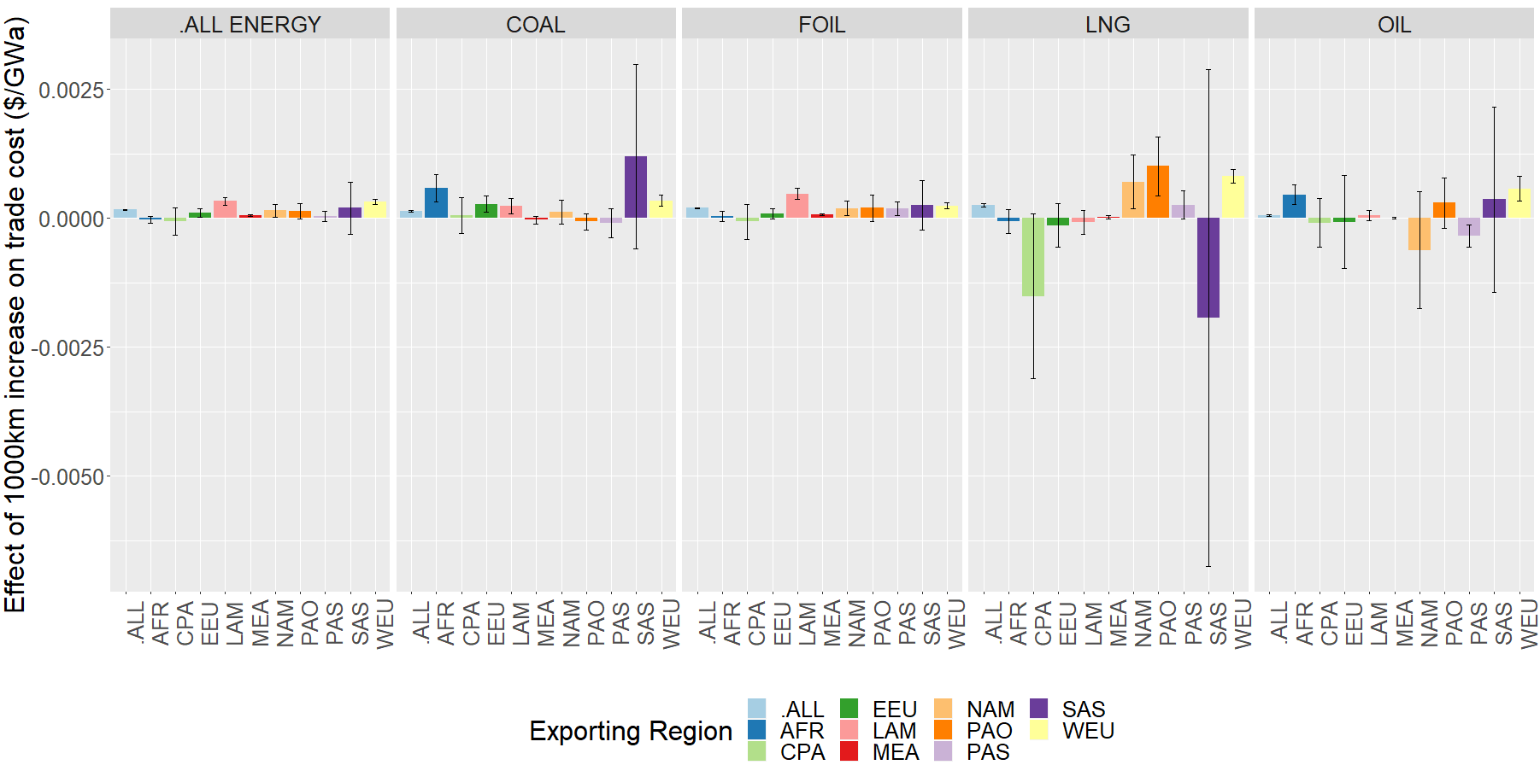

**Fig. 4.** Results of a gravity model-based regression of trade cost ($/GWa) on distance. The regression is run across region (“ALL”), and then by region. Different colors represent different regions. The regression is also run across all energy commodities (first column), and by energy commodity. FOIL represents fuel oil, OIL represents crude oil. Errors bars represent the 95% confidence interval on the results. The bars presented here are equivalent to $β_{1}$ of the regression specification in the main text.

# 11 Table: Policy effects on the energy trade network

The table below presents the effects of the six examined scenarios discussed in the main text. This table corresponds to the discussion in Section 3.1. This table outlines key network metrics for 2050. In this network, nodes represent regions and edges represent directional trade flows.

|  |  |  |  |  |  |  |
| --- | --- | --- | --- | --- | --- | --- |
|  | **(1)** | **(2)** | **(3)** | **(4)** | **(5)** | **(6)** |
|  | **Baseline** | **High tariffs** | **Low tariffs** | **Emissions tax + baseline tariffs** | **Emissions tax + high tariffs** | **Emissions tax + low tariffs** |
| **Global energy system cost** | 2528475.28 | 2563606.78 | 2517104.10 | 128160362.83 | 128201829.80 | 128149153.81 |
| **Total number of exporters** | 11 | 11 | 11 | 11 | 11 | 11 |
| **Total number of importers** | 12 | 12 | 12 | 12 | 12 | 12 |
| **Total number of links** | 111 | 106 | 113 | 183 | 185 | 180 |
| **Total amount of trade (EJ)** | 178.15 | 158.12 | 187.6 | 96.36 | 88.42 | 98.04 |
| **Mean trade flow (EJ)** | 1.6 | 1.49 | 1.66 | 0.53 | 0.48 | 0.54 |
|  | 3.99 | 3.9 | 4.11 | 2.14 | 1.85 | 2.08 |
| **Minimum trade flow (EJ)** | 0 | 0 | 0 | 0 | 0 | 0 |
|  | PAO to UBM | PAO to UBM | PAO to UBM | UBM to PAO | UBM to PAO | PAO to EEU |
| **Maximum trade flow (EJ)** | 20.7 | 20.39 | 22.98 | 24.54 | 18.54 | 23.57 |
|  | MEA to SAS | MEA to PAS | MEA to SAS | LAM to SAS | LAM to SAS | LAM to SAS |
| **Mean # of edges per node** | 18.5 | 17.67 | 18.83 | 30.5 | 30.83 | 30 |
|  | 4.7 | 4.83 | 4.99 | 8.48 | 8.61 | 8.81 |
| **Outdegree centrality** | 0.21 | 0.2 | 0.21 | 0.3 | 0.31 | 0.3 |
|  | 0.1 | 0.08 | 0.1 | 0.1 | 0.1 | 0.1 |
| **Indegree centrality** | 0.16 | 0.16 | 0.17 | 0.26 | 0.26 | 0.25 |
|  | 0.05 | 0.05 | 0.06 | 0.08 | 0.08 | 0.08 |
| **Size of energy-specific trade** |  |  |  |  |  |  |
| **Coal** | 19.62 | 18.49 | 20.13 | 4.1 | 4.1 | 4.1 |
| **Ethanol** | 0.02 | 0.42 | 0.01 | 1.65 | 1.68 | 1.63 |
| **Fuel oil** | 3.97 | 4.07 | 4.02 | 2.15 | 1.76 | 2.32 |
| **Light oil** | 0.03 | 0.01 | 0.08 | 40.54 | 34.88 | 40.21 |
| **LNG** | 56.7 | 48.33 | 62.48 | 8.16 | 8.16 | 8.16 |
| **Crude oil** | 97.81 | 86.79 | 100.87 | 39.75 | 37.83 | 41.61 |

**Table 11.** Network metrics for the global fuel trade network in 2050.

1. A map of nodes (both uniform and sea/inland ports) can be found in the Supplementary Material.
2. We also run a specification by exporting region but find that there is too much uncertainty in our results to use a region-specific effect. Results of the region-specific effect can be found in the Supplementary Material.